**CONFIGURE SQL DEVELOPER TO ACCESS HIVE**

* Step 1, Logon cloudera manager and click [clusters] menu and choose Hive menu item.

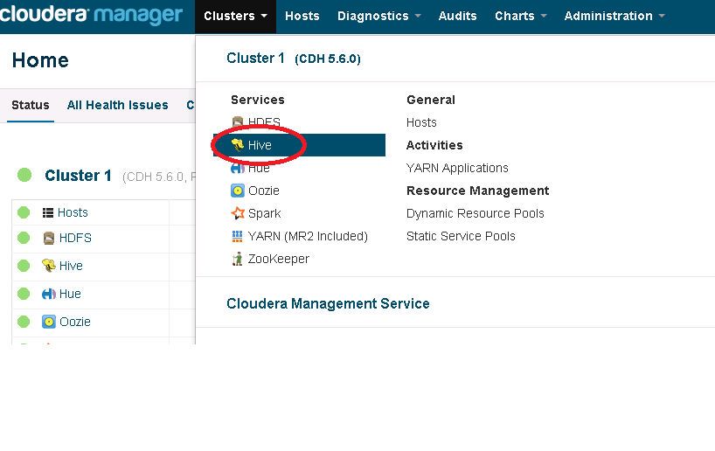

* Step 2, Click [Instances] Tab and find out hostname of HiveServer2

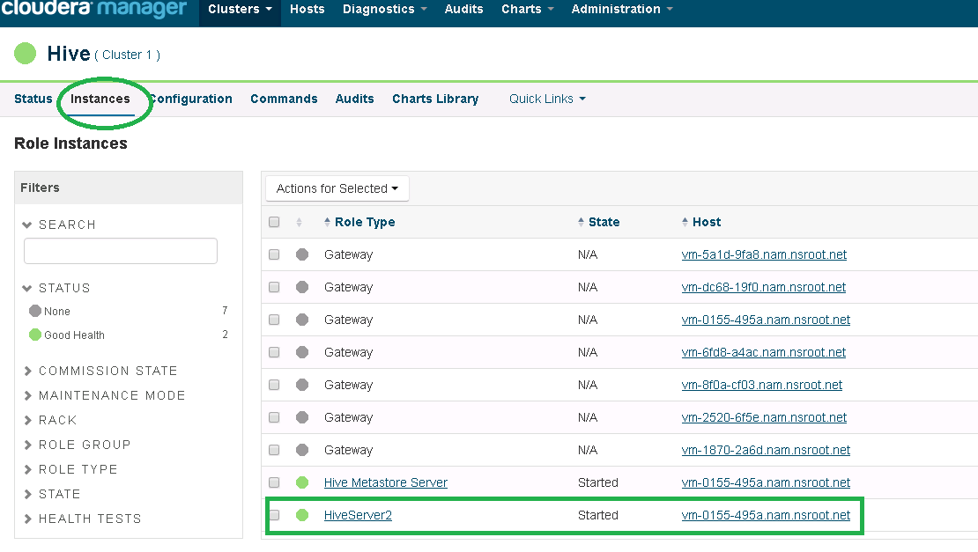

* Step 3, Click [Configuration] Tab and input “Hiverserver2 port” in search box and find out port number

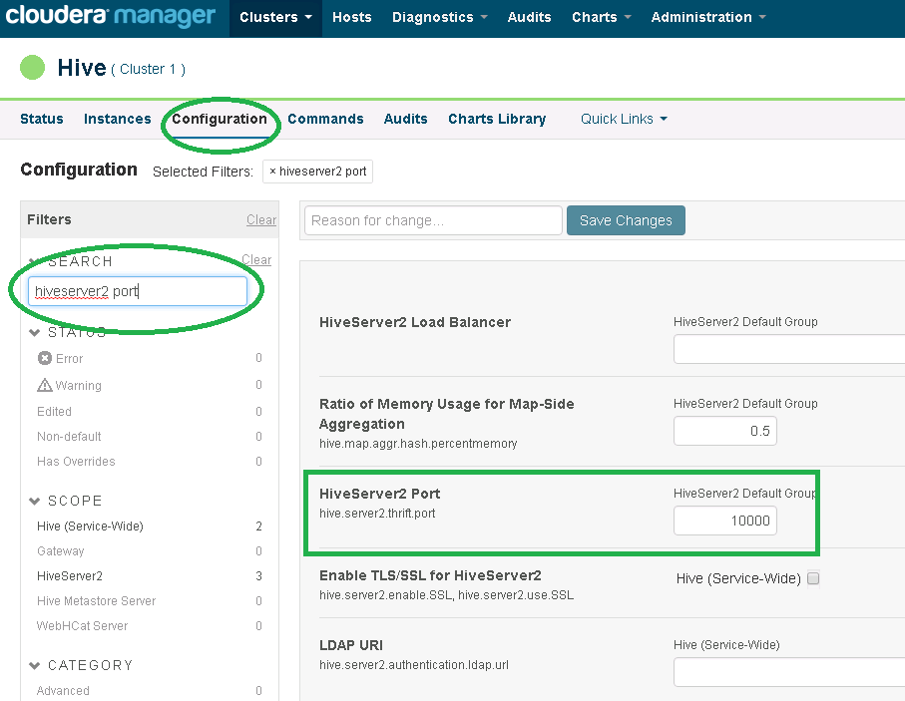

* Step 4, Lunch oracle SQL developer, open [prefereences]

**Version of Your SQL developer must be greater than 4.0.3**

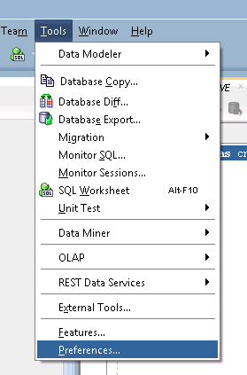

Click ‘Add Entity’ to add all HIVE jars:

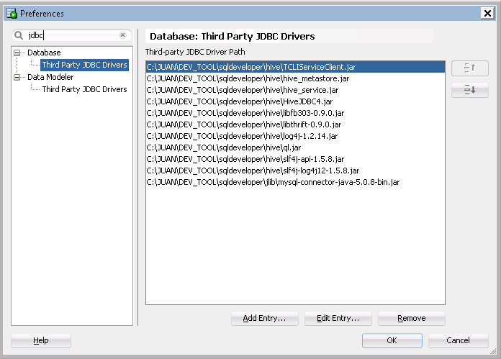

You can find all HIVE jdbc jar in SVN

<https://svn.nam.nsroot.net:9050/svn/165637/FnBackbone/dbcode/subgl/Hadoop/clouder_hive_jdbc>

* Step 5, create new connection for hive server.

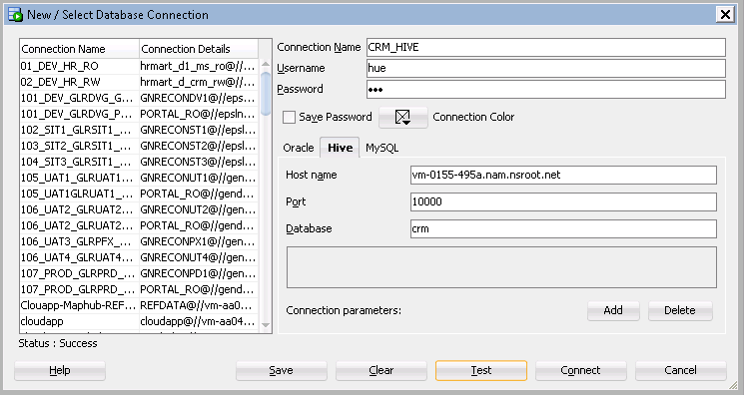

* Step 6, execute sql to verify the jdbc connection.

